Professional skills

end-of-project retrospect

**Retrospective of Johnson Domacasse**

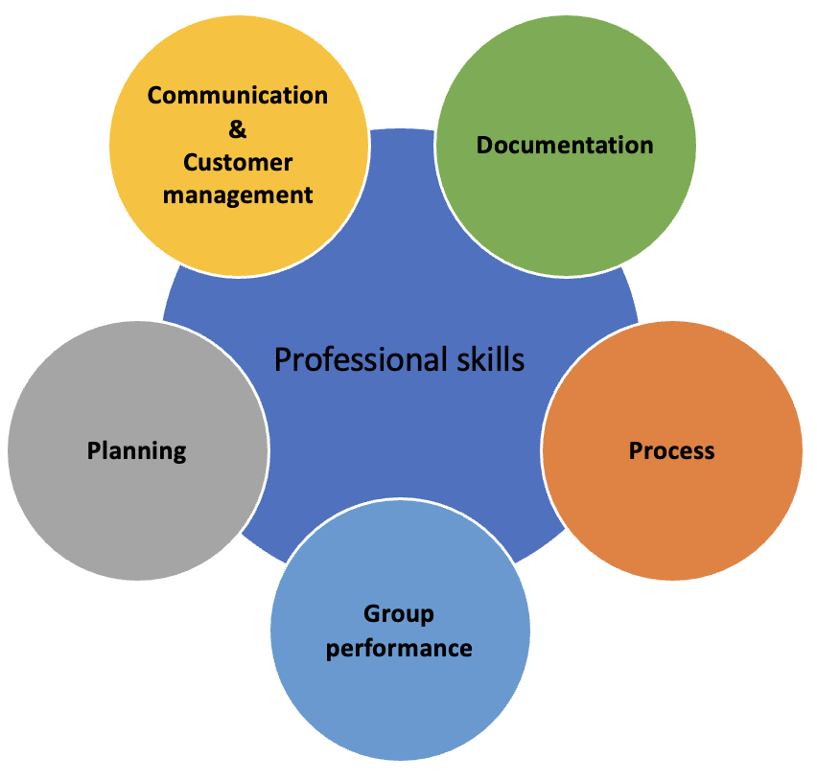

**Team name:** *<Psychopaths>*

**Team members:**

*<Johnson Domacasse, #483564>  
<Tim van Kol, #507844>  
<Ard Kraak, #505362>  
<Adrian Pacera, #>  
<Peter Szilagyi, #>*

**Document date:** *<2023-06-13>*

# **Contents**

1 Contents 1

2 Group reflection 2

2.1 Team organisation 2

2.2 Team reflection 2

3 Individual reflection 3

3.1 Project Role and responsibilities. 3

3.2 What was your contribution to the project 3

3.3 Group work 3

3.4 Your suggestions for next semester 3

4 Grade 3

# Group reflection

## Team organisation

Our team organization was as follows:  
Johnson - Team Leader

Adrian - C developer

Ard - C developer

Peter - C# developer

Tim - C# developer

The way our project process went per day was something along these lines. Before every project day, Johnson would remind everyone what the tasks. The tasks were also put up and managed on Trello. The deliverable reviews from the teachers were always taken into account and everything was then updated according to their feedbacks. Everybody would then work on their designated tasks throughout the day. At the end of the day, an update is given on their progress. An update can also be asked for sometimes in the middle of the day. These updates are in the form of standups.

We were advised to use important tools to keep track of all our work. We knew we needed to work with some type of environment to keep our codes in. We settled on the GitHub platform because at the time, Tim knew a decent bit about it. We also used Trello to keep track of our deadlines and tasks.

## Team reflection

This was a fun project as a whole. The requirements of the project were quite detailed. Achieving these requirements were not challenging in the end. The issue for me personally was the sprints. Sometimes the sprints would ask us to do something that we haven’t learned about yet until that week. Take for example sockets. In this situation we needed to perform the project sending using sockets instead of UART. The issue here is that we learned sockets in the same week as the sprint deadline. It becomes hard to perform up to that standard. So some feedback I would give is to check the next sprint requirements a bit better and see if they are in line as the other courses. Aside from that I would say that this was a rather fun project to work on when we found out exactly what we had to do.

**Ard:**

Ard was a good group mate all around. He was always present on project days. He always kept himself busy with one or the other aspect of this project. He always delivered proper files needed for each sprint. I don’t think I have any cons to say here. Some feedback I would give Ard would be to continue this work style throughout his entire school career. His professional work ethic is good to have around in a project.

**Adrian:**

Adrian was a good group mate. Adrian was always present on days of project days. He decided to take on the most difficult task early on so the group could focus on different aspects of this project. When he was done, he provided us with a good base to work with the stepper motors. The only issue I would say Adrian has is his tardiness. One thing is good, is that he always let’s us know when he will arrive. His work would also compensate for if he is late as well. My feedback to Adrian would be to try and be on time more and more. Start small with 1 out of the 5 days and work his way up.

**Peter:**

Peter was a good group mate at the end of the project after we had a talk with him about his behaviour. It showed good growth on his part. In the beginning he would not be assertive, he would not take initiative nor would he vocalize what he needed to do. We had the talk with him and he started being more “present”. He would even go as far as asking me what he can do to further his contribution to the project. I gave him tasks and he improved significantly with his assertiveness. My feedback to Peter would be to continue with this improvement on his work behaviour. Try to be more present, ask for what needs to be done and at some point even take on a role of a leader.

**Tim:**

Tim was a good group mate. In the beginning there was not much to do regarding C# applications so naturally Tim didn’t have much to do. That didn’t stop him from helping around where he could with the report and with other aspects of the project. When it came time to build the C# application, Tim did not disappoint. We were all happy with the results. One thing I think Tim needs is patience. He can get easily frustrated if things (code) don’t go his way. This can be loud and distracting. My Feedback to Tim would be to build up some and be more patient when working in a project group. Aside from that all I have to say about Tim is positive.

What the group did well was work properly on their tasks when they knew what their tasks were. I liked that we had a the time to quickly review per project day, which of the tasks needed to be finished or done. I like how everyone made everything work together. Each person had their tasks and they delivered amazingly. When the group was functioning at 100%.

# Individual reflection

### 

## Project Role and responsibilities.

The list of responsibilities I decided to take was being the group leader and taking on the documentation of the entire project. As the leader I’d like to think I did a great job when I was taking it seriously. The documentation to me was also one of my responsibilities. I found it quite fun as other found it tedious so I decided at some point to take the full responsibility of it. I made sure that the document was always updated and all of the received feedback was incorporated. Initially I also worked on one or two sensors to be put into our project. Mainly the BME sensor working with the fan.

## What was your contribution to the project

The main things I contributed to this project were delivering my sensor codes in the first few months of the project. In the middle I took over the documentation and that became my full responsibility. The sensors I was responsible for were then temperature sensors. Since I had to do my research on an NTC sensor, I transferred this research to my teammate. Along with this the base of the code I used for my research.

I brought my knowledge on writing proper reports and handling conflicts in a calm manner. Outside of these I would say that I had learned more skills than I brought into the project.

## Group work

In this project specifically, I learned how conflicts can be solved. I previous ones everyone would just completely ignore the problem in order to finish the project. In a way that does work however I would say the environment in which you work is not fun. So I learned how to solve a new conflict with this project. I also concluded that no project group is perfect. There will always be some type of anomaly that can hinder your work. Accepting this made working in this setting easier.

We faced the conflict of a teammate “not working” alongside us in the project. This was quite annoying since we had to put their name on the final report as well. It doesn’t feel well to give someone credit for something they did not do. The way we handled it was confronting him about it. We gave him some suggestions on how he can fix his attitude and in my opinion he did indeed change.

Personally, what I could’ve done to improve my performance would be to be there for my teammates more than I was during this project. As previously mentioned, I was demotivated and I feel like that not only hindered my performance but that of my team’s as well. Aside from this it’s mainly things I can put into practice. Like working using agile/scrum. I would continue with how I am as a leader when I am serious.

## Your suggestions for next semester

One meaningful suggestion I would give for the next semester project course would be to double check all the requirements that are asked of us. Check if they fall in order with other subjects. I would say let us learn about the subject a week prior for example and the week after we can have the opportunity to present it in the project. Additionally, I liked the load of the project in this semester. They don’t feel like they take up all of your time. They feel just right so I would say to continue with this.

# Grade

What grade do you think the group and you deserve. Use U-S-G-O ((U)Insufficient, (S)Sufficient, (G)Good, (O)Outstanding.

Group: G

You: G

The reason for giving the group G is because I think we did pretty well all around. The group it self performed up to standard when it came down to professionalism. So that is sufficient. But because even though we were doing the bare minimum we didn’t stop there. We put in extra work that was intended I would say and that’s why we deserve G.

The reason for giving myself G is because even though I didn’t not perform my duties in the period of demotivation, I did make up for it by taking on some extra responsibility In the end. That is the reason for the good. In the beginning I did the bare minimum in order to pass but as I see my groupmates working hard, that also gave me motivation to continue hard at work.

A small side note, the G was also given as a kind of average for the group. There are 2 teammates I think performed outstandingly, 2 doing good and 1 doing sufficient. I took the average of that and came with G.